DBMS Technical Task
Dhanalakshmi K
E25AI110
BSc. Computer Science
With
Artificial Intelligence

Week 8: Database Relationship Analysis using Joins

Scenario:
The e-commerce company stores customer, product, order, and payment information in separate tables. The management team wants to combine these related tables to understand customer purchases, order details, and payment status.

- Implement INNER JOIN
Tasks:
- Display customer details along with their orders. 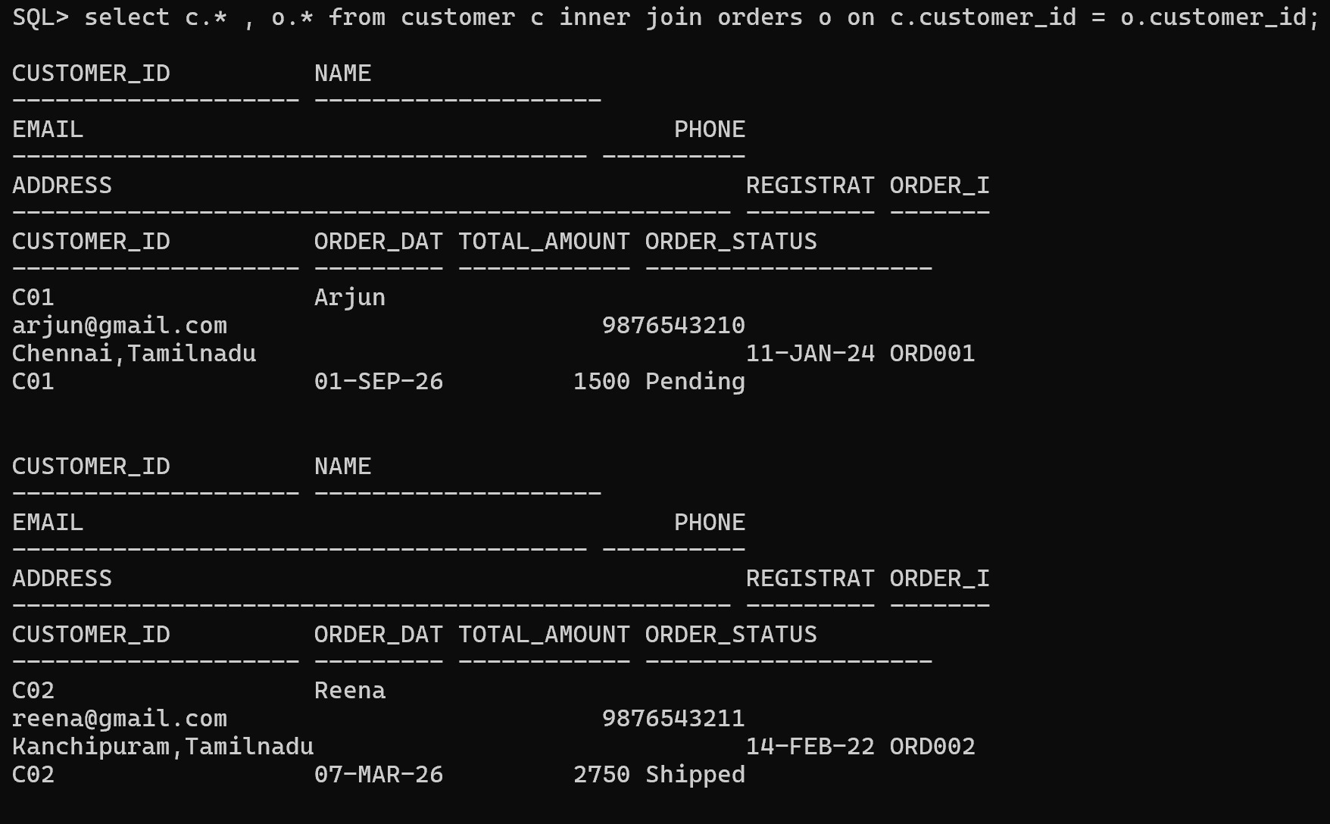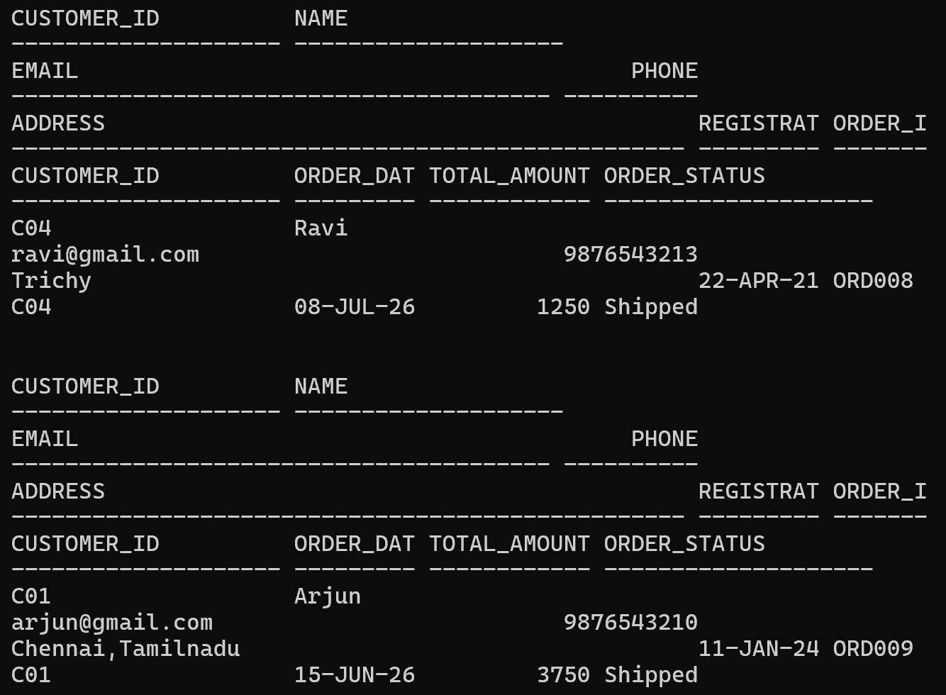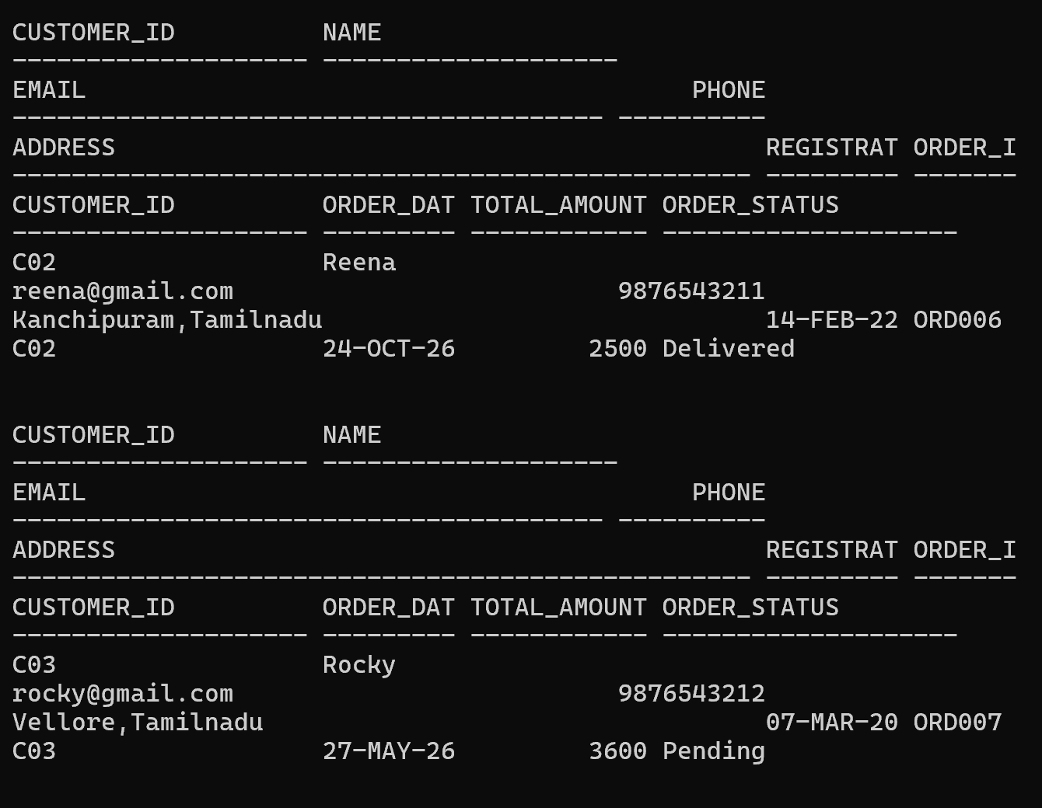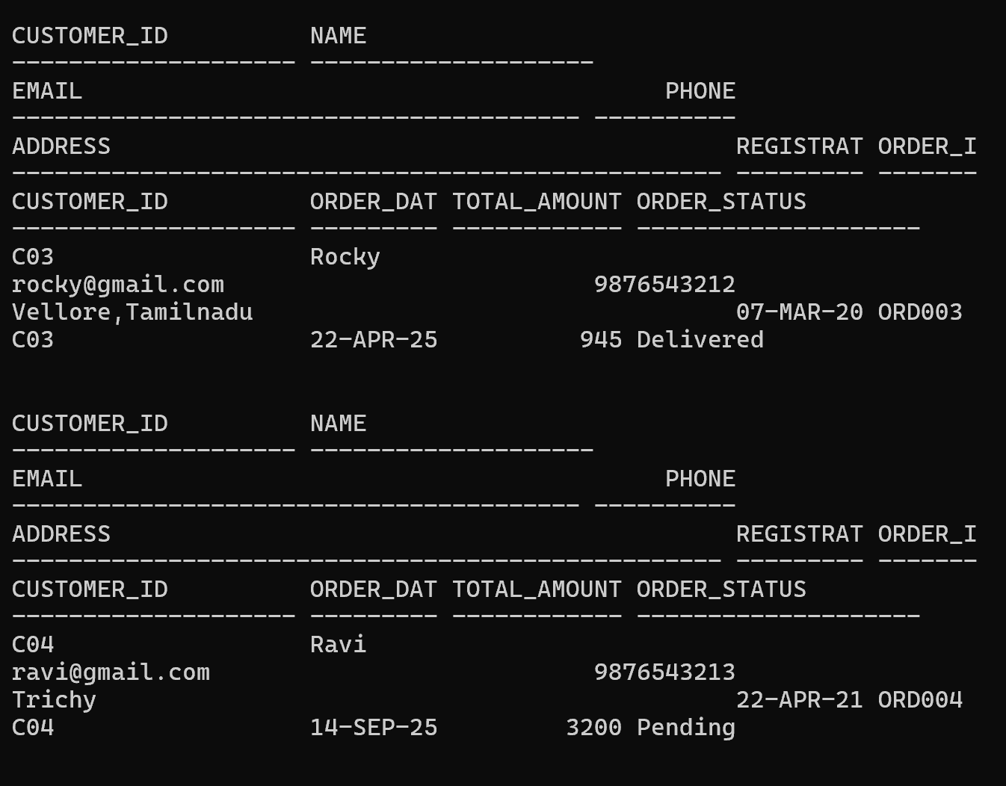 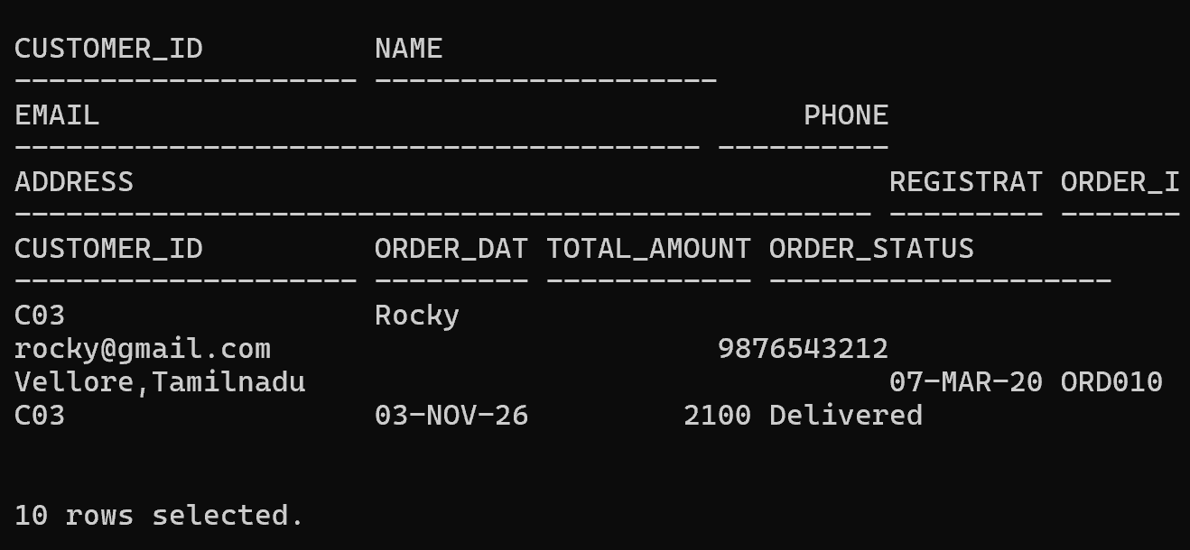

- Display order details with payment information.
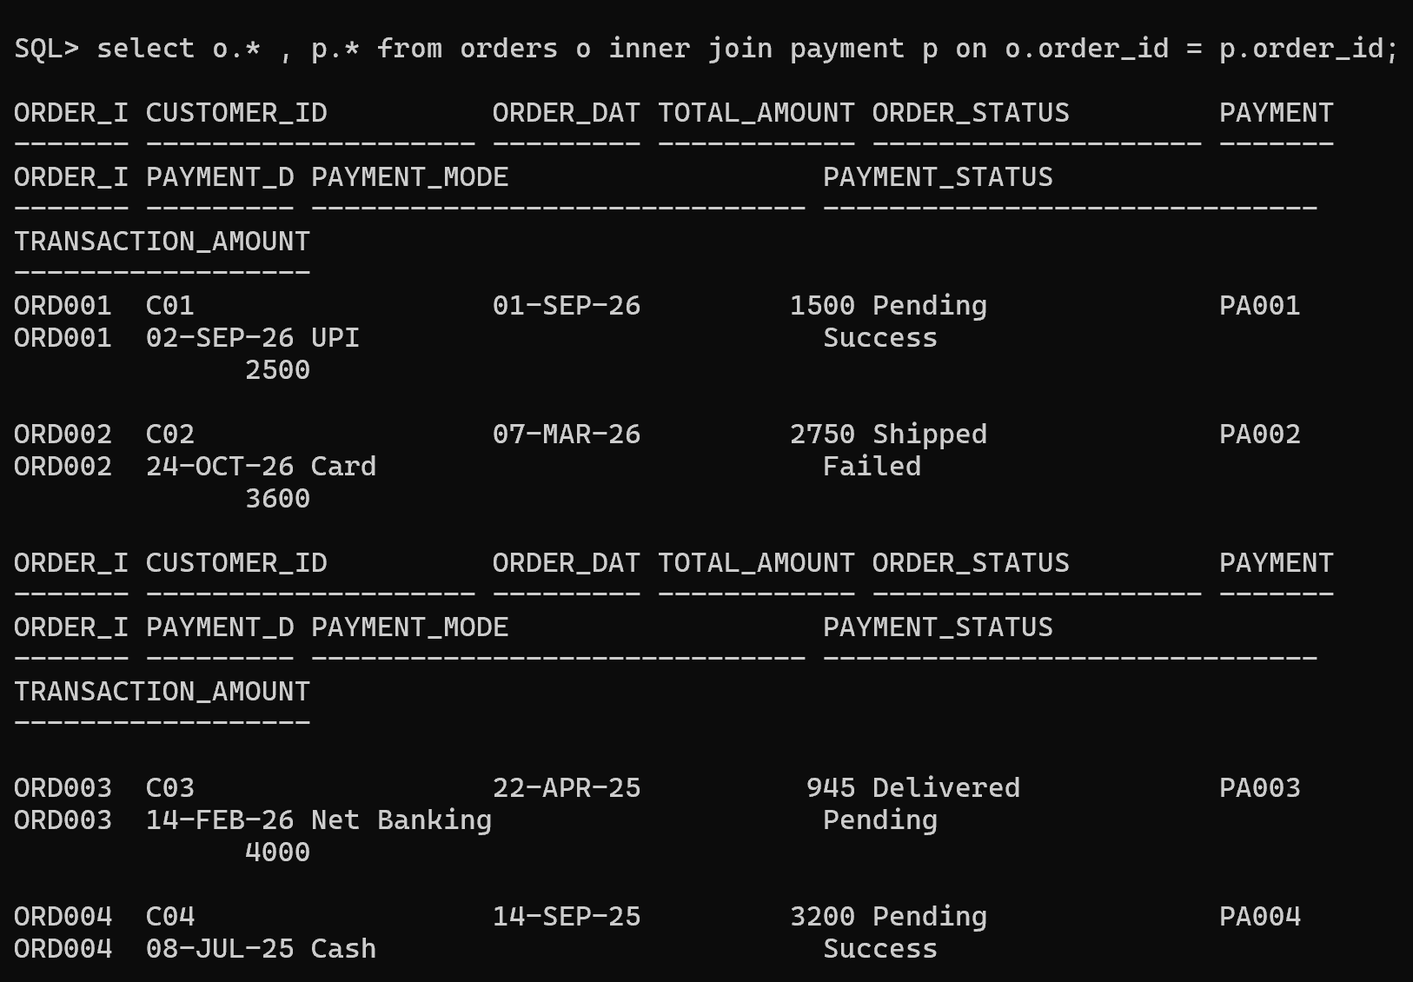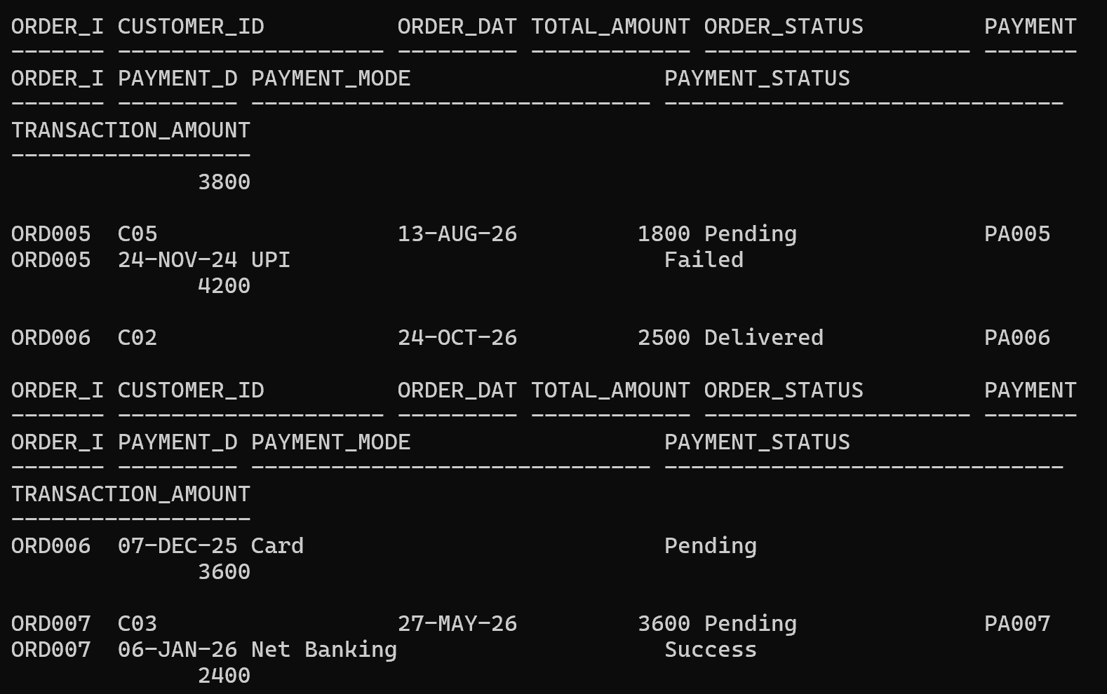
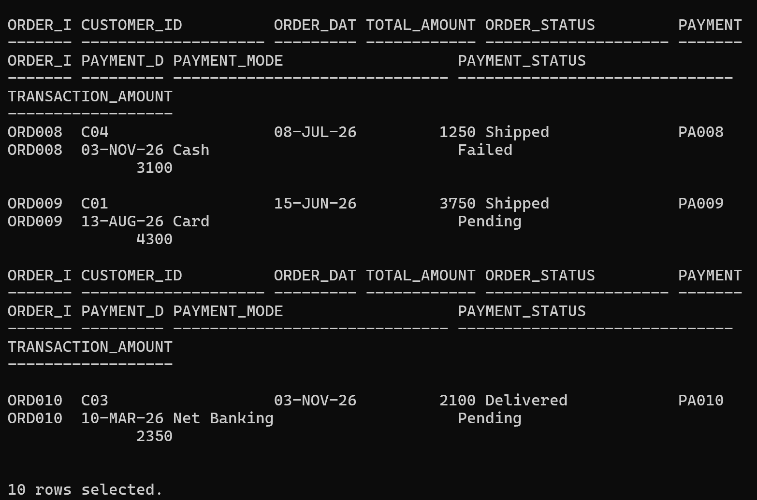

- Retrieve products purchased by customers.
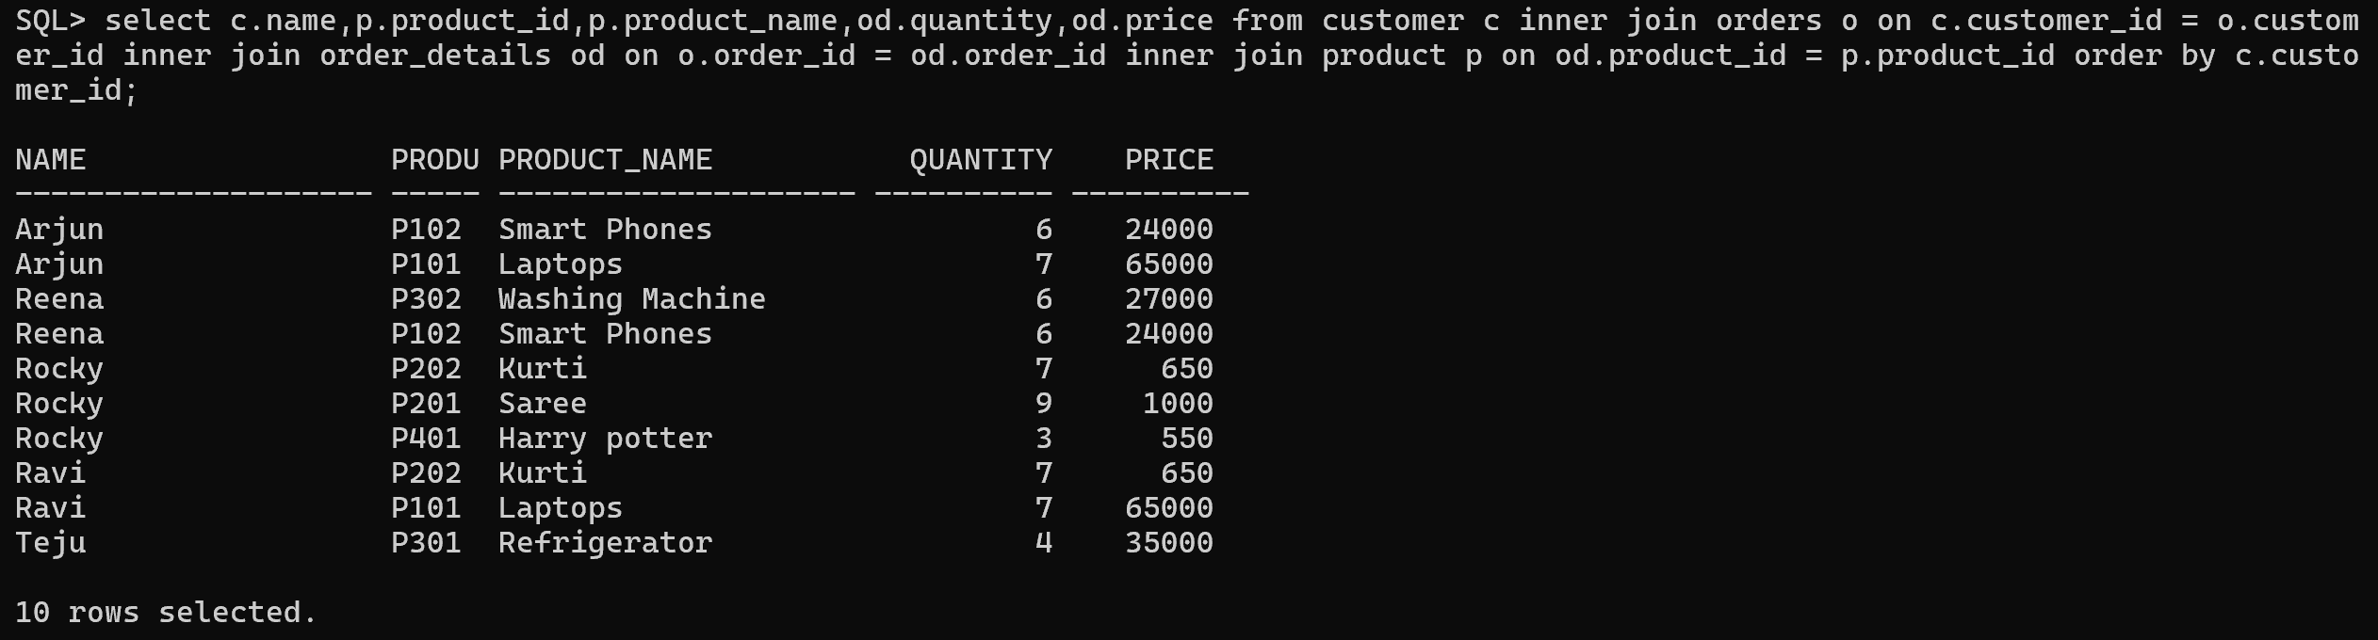

2.Implement LEFT JOIN
Tasks:
- Display all customers including customers who have not placed orders.
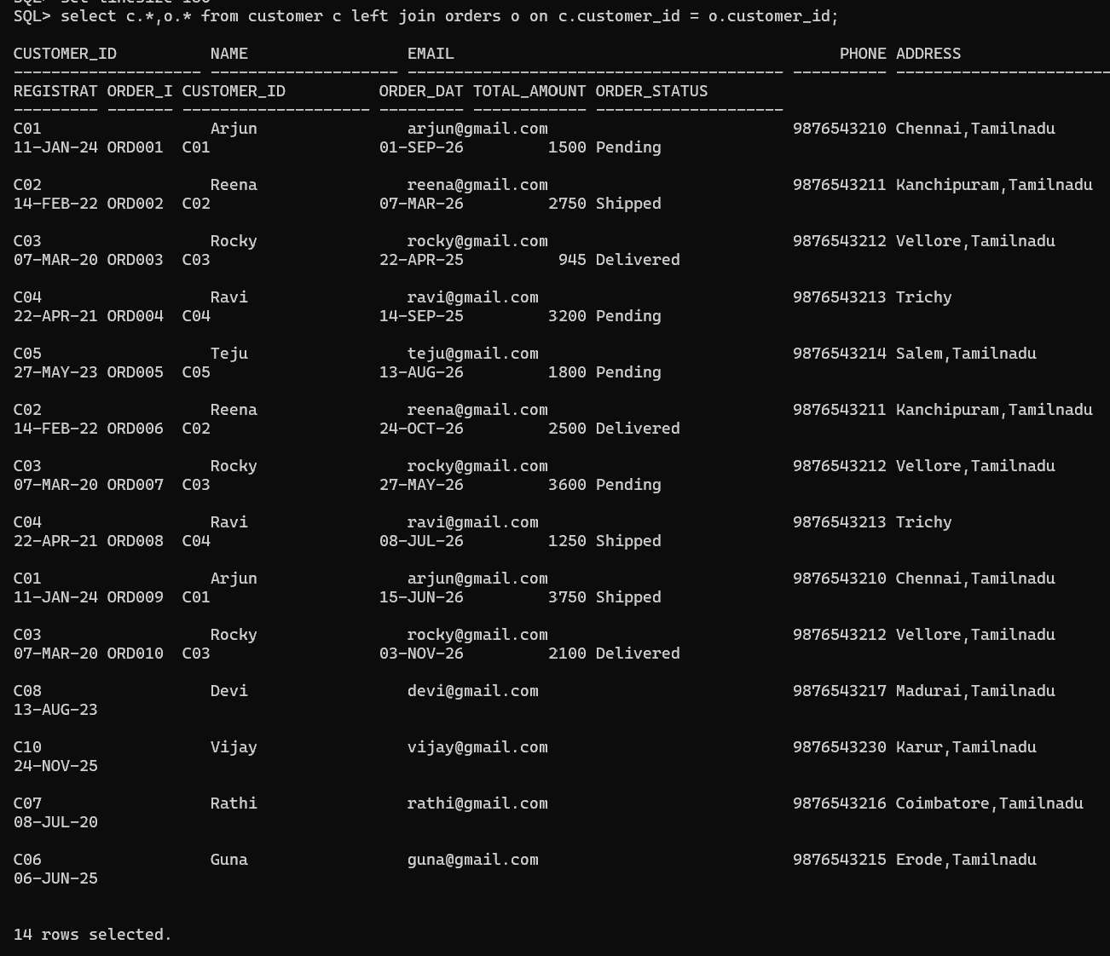

- Find customers without any purchases.
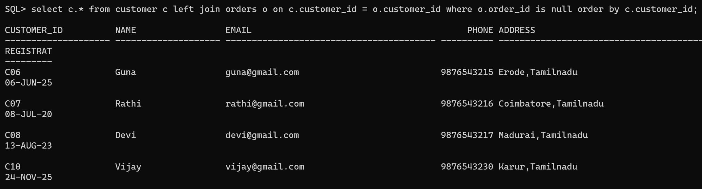
- Display all products including products with no sales.
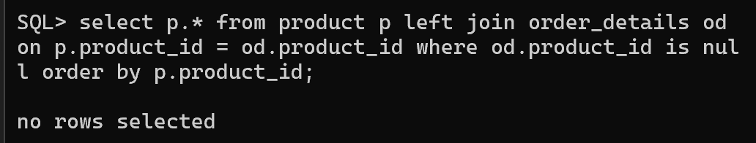
3.Implement RIGHT JOIN
Tasks:
- Display all orders with customer information.
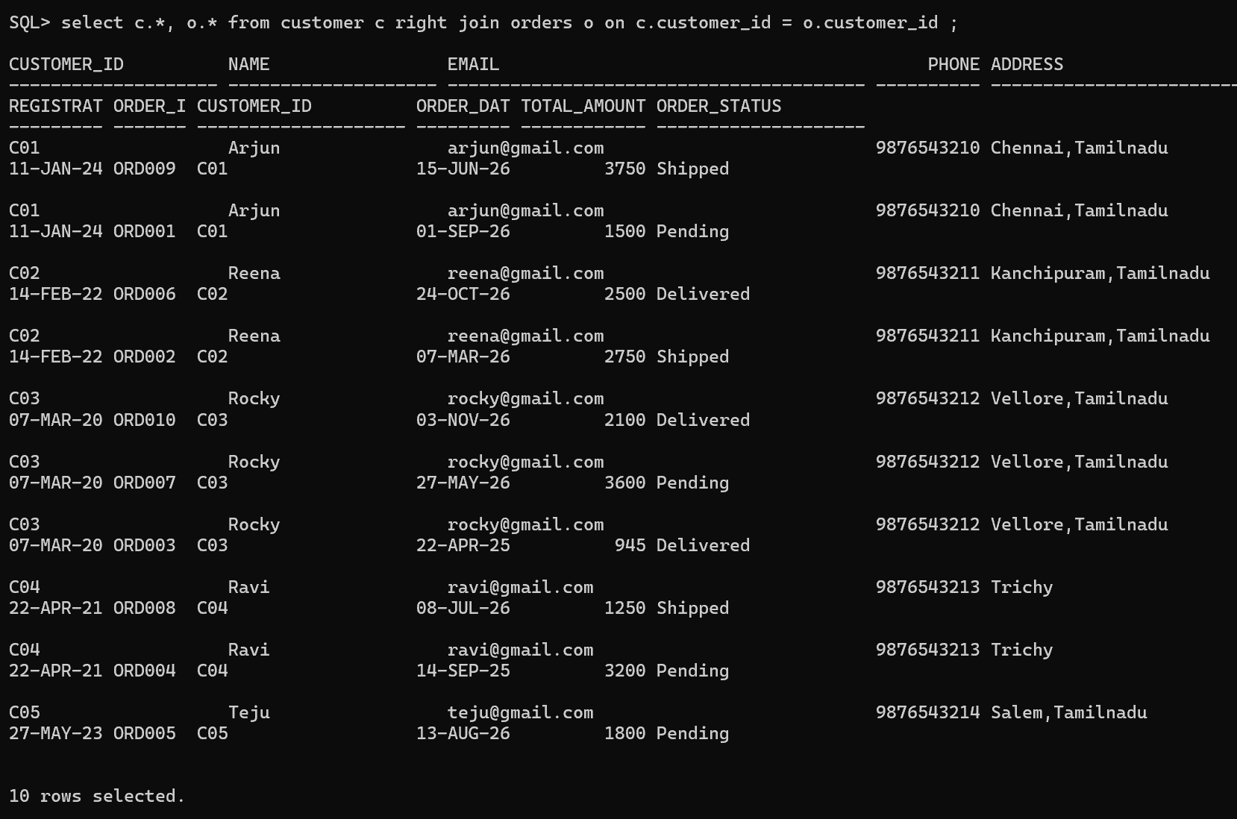
- Find orders where customer details are missing.
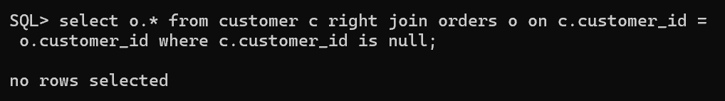
- Display all payment records with order details.
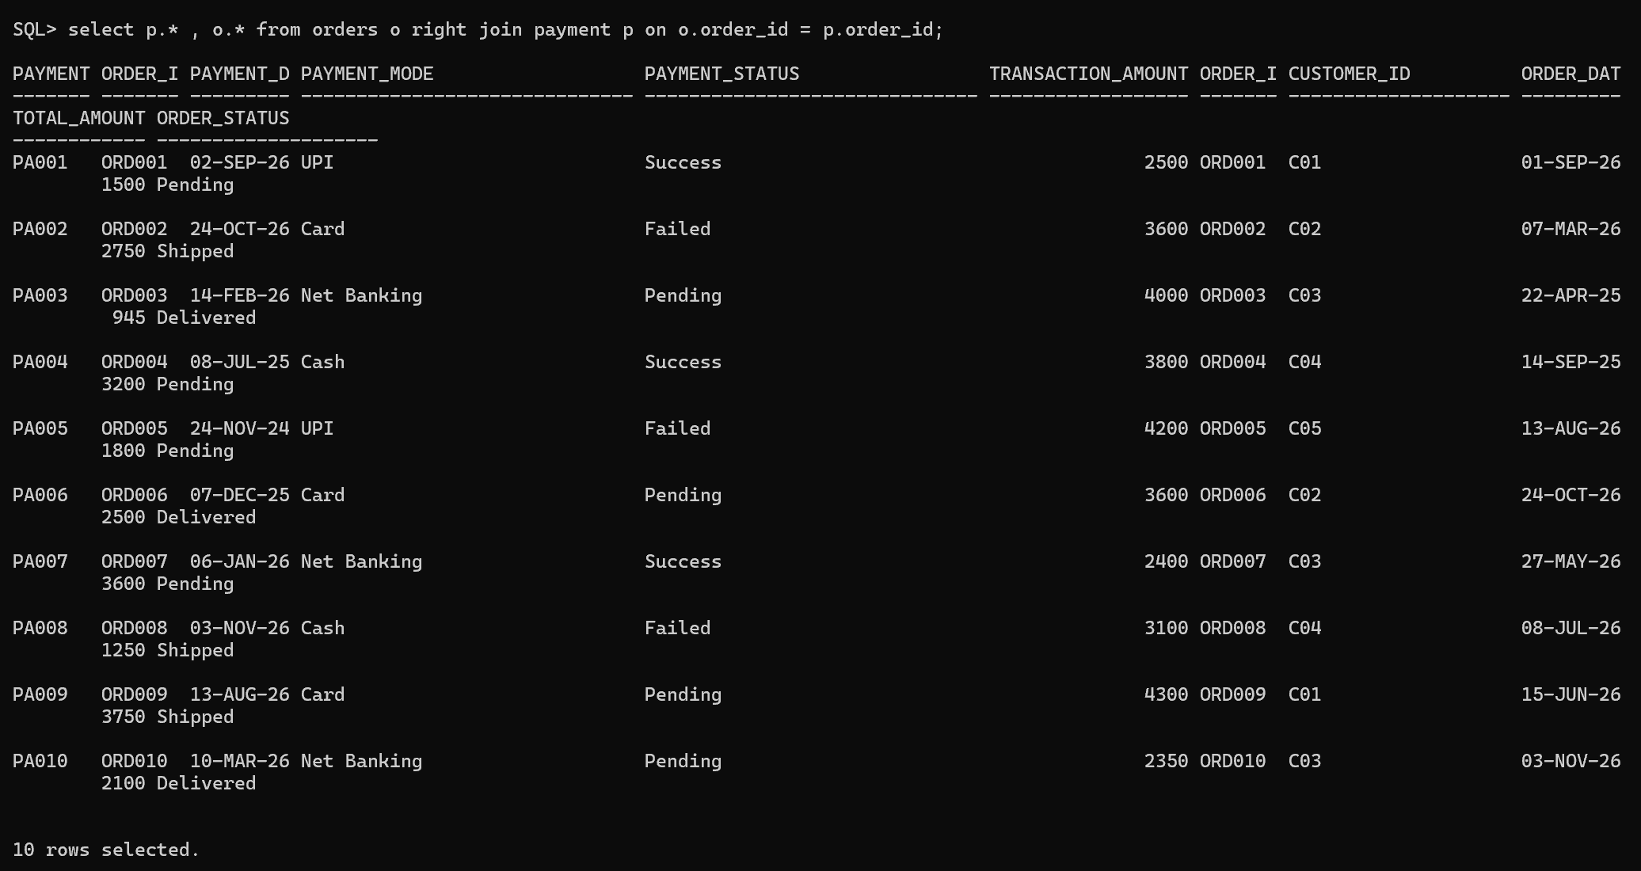
4.Retrieve Complete Order Details
Task:
Generate a complete order report by combining:
- Customer
- Name
- Product Name
- Quantity
- Order Date
- Total Amount
- Payment Status
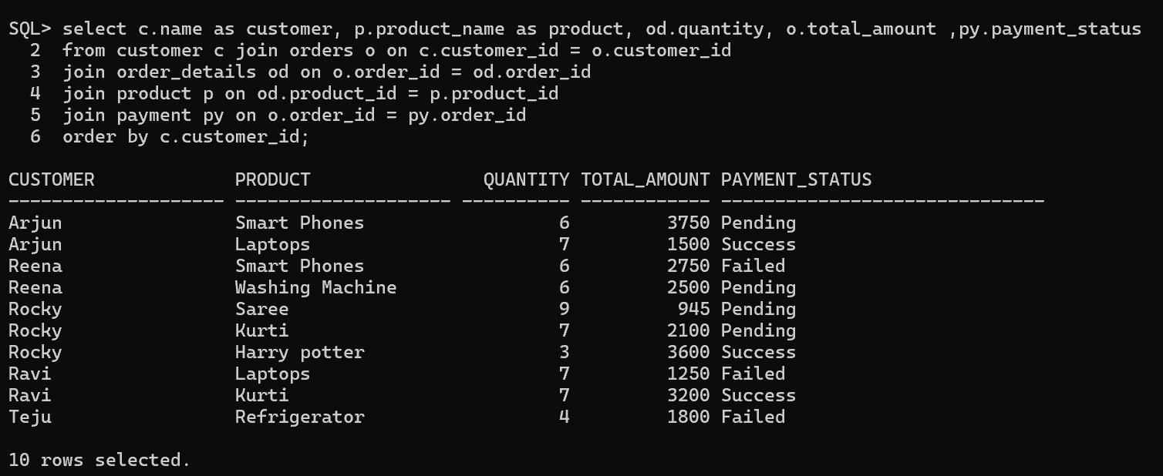
5.Display Customer Purchase History
Tasks:
- All products purchased by a customer.
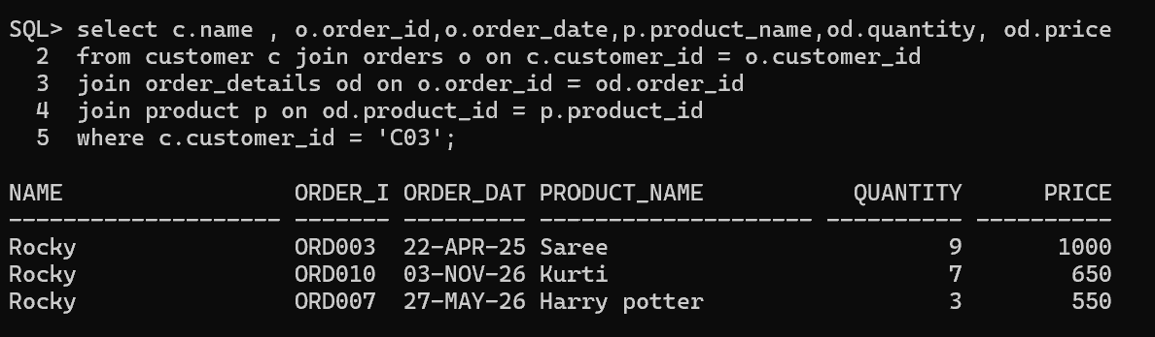
- Total amount spent by each customer.
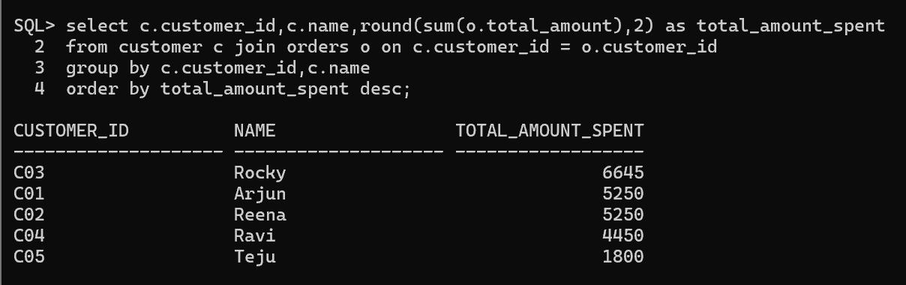
- Number of orders placed by each customer.
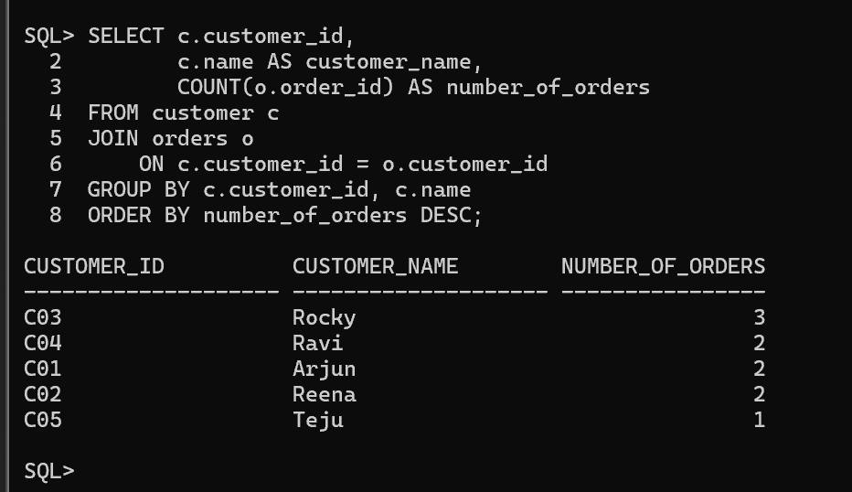
4.Latest purchase details of customers.
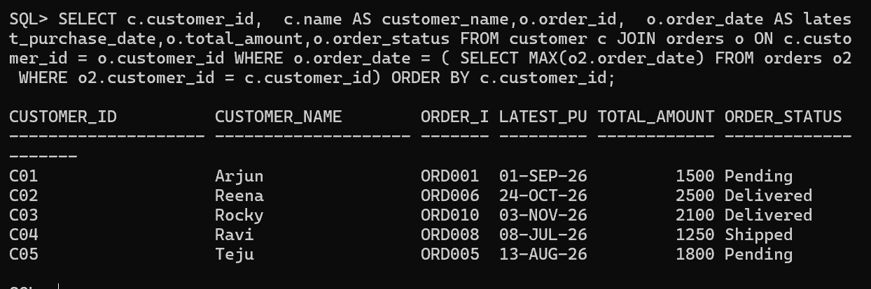

6. Generate Multi-Table Business Reports
Report 1: Customer Order Report
Display:
- Customer name
- Order ID
- Order date
- Order status
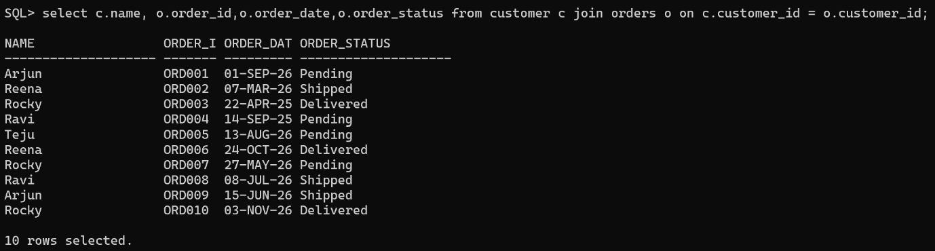
Report 2: Sales Report
Display:
- Product name
- Quantity sold
- Total revenue
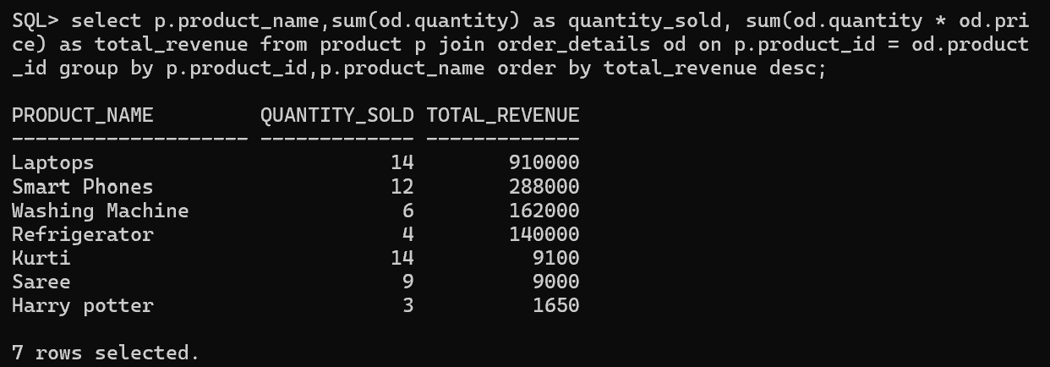

Report 3: Payment Analysis Report
Display:
- Payment mode
- Number of transactions
- Successful payments
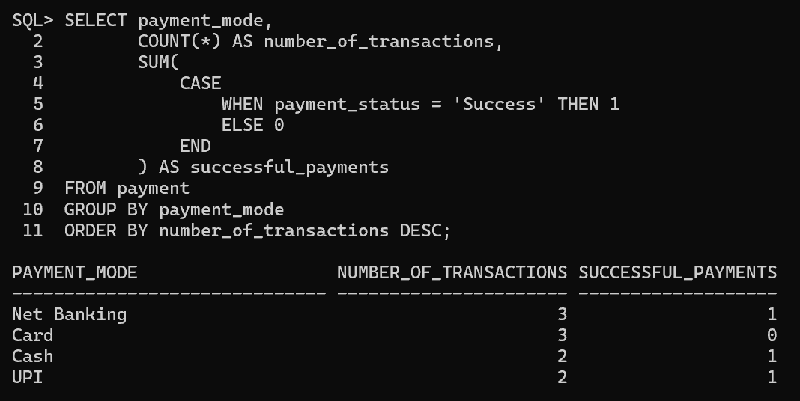

Report 4: Customer Purchase Analysis
Find:
- Top purchasing customers
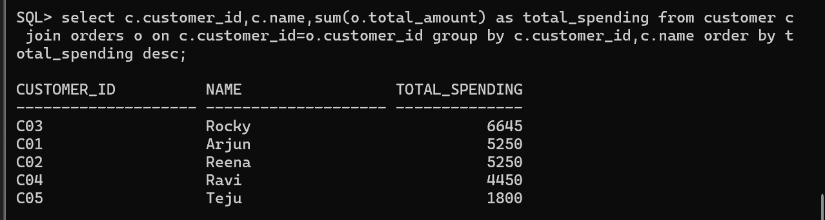
- Customers with maximum orders
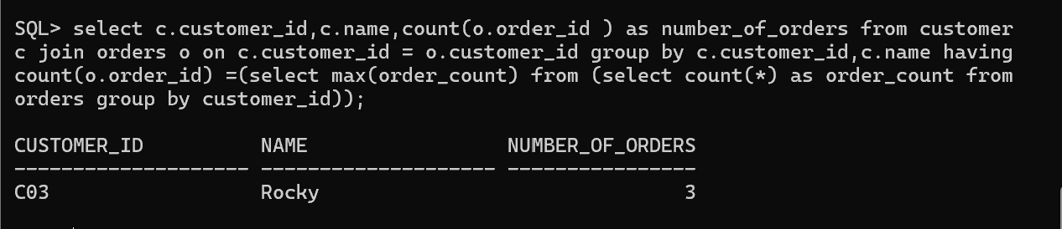
- Customers with highest spending
